Steps for basic Setup on your machine

- Create a new folder named “SmartSchoolProject”
- Now under “SmartSchoolProject”, create 2 new folders named “SmartSchoolProject-GIT” and “SmartSchoolProject-Coding”.
- Copy Eclipse, postgresql database, Apache Tomcat, Maven installation files onto a folder.
- Download latest java jdk from Oracle downloads.
- Install jdk on your environment.
- Now install eclipse on your machine and point the workspace of the eclipse to the “SmartSchoolProject-Coding” (which we created above in step-2).
- Now install postgresql database on your machine. (give the database password as 'postgres')

Steps for Maven Setup :

- follow the steps defined on web page : http://www.mkyong.com/maven/how-to-install-maven-in-windows/

Setup for GIT Repository in Eclipse:

  - Follow the below screenshots for importing Maven into Eclipse :

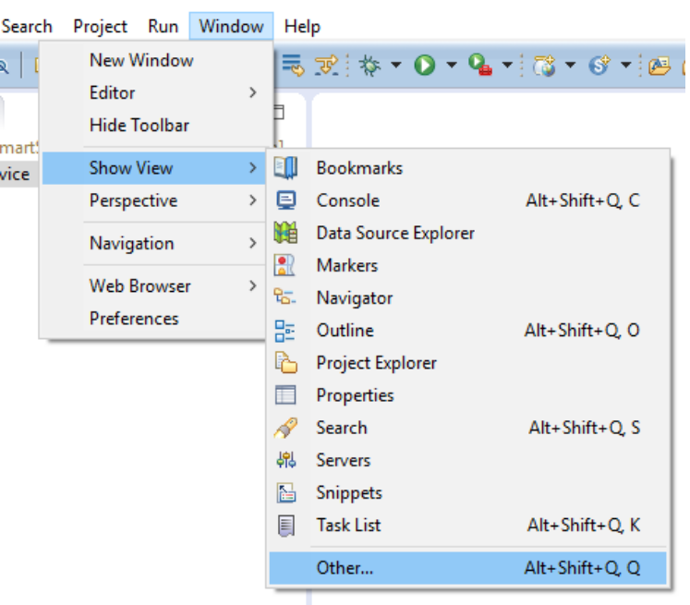

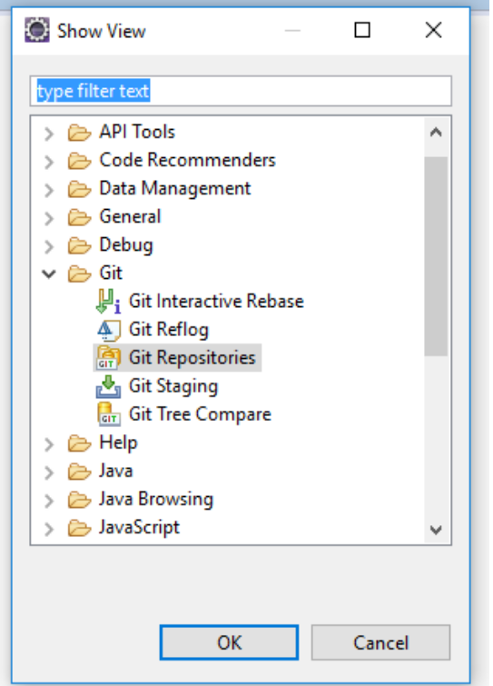
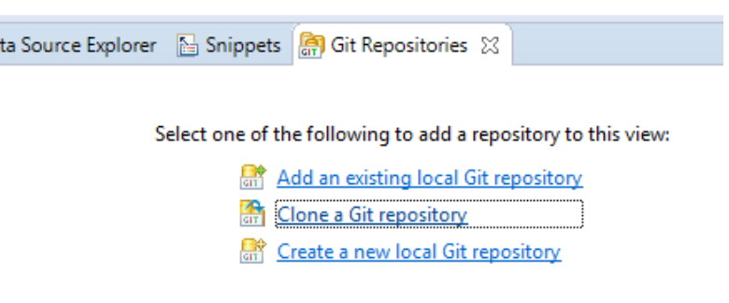

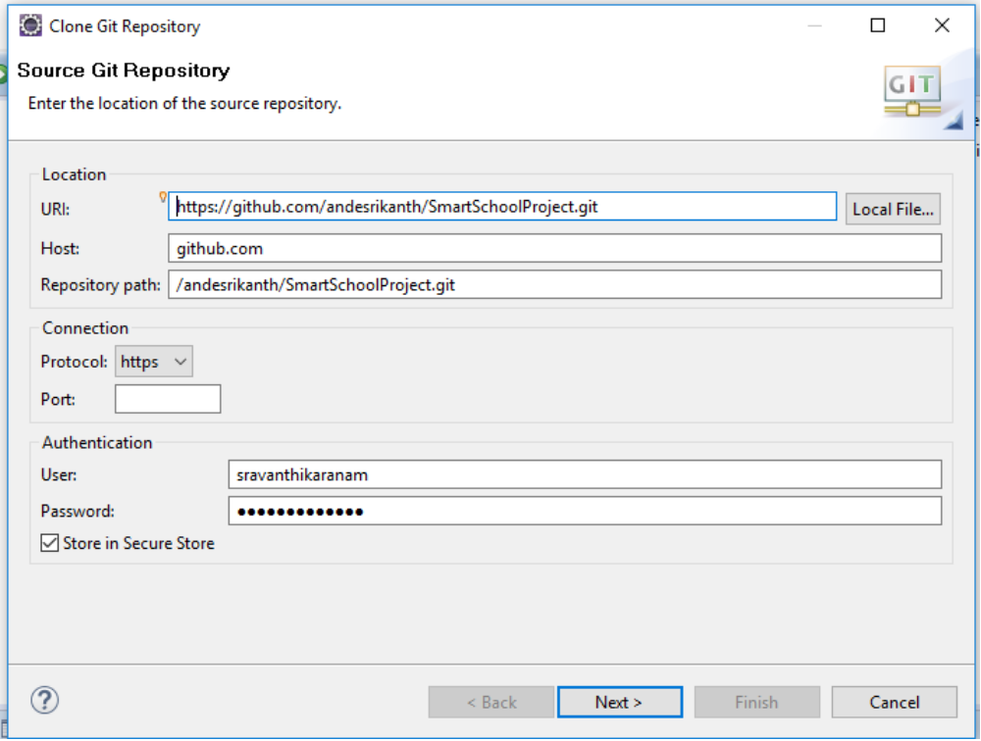

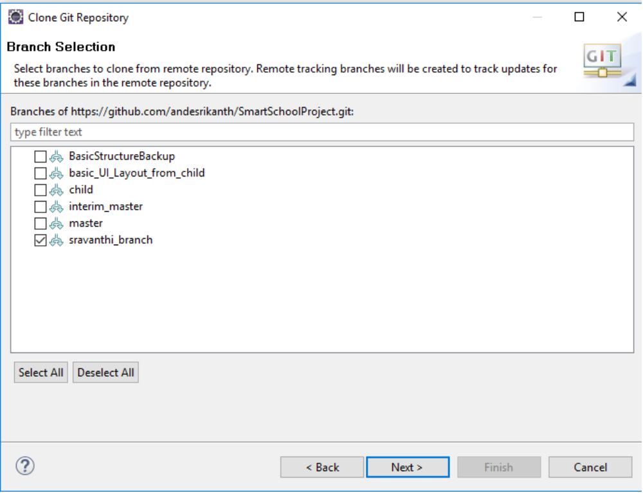

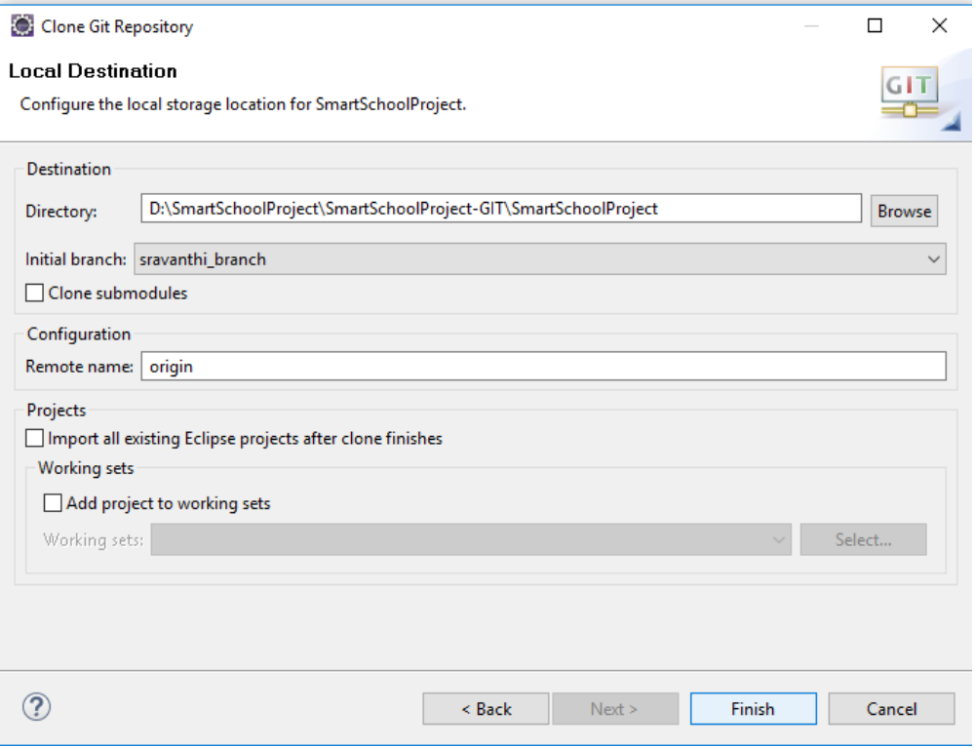

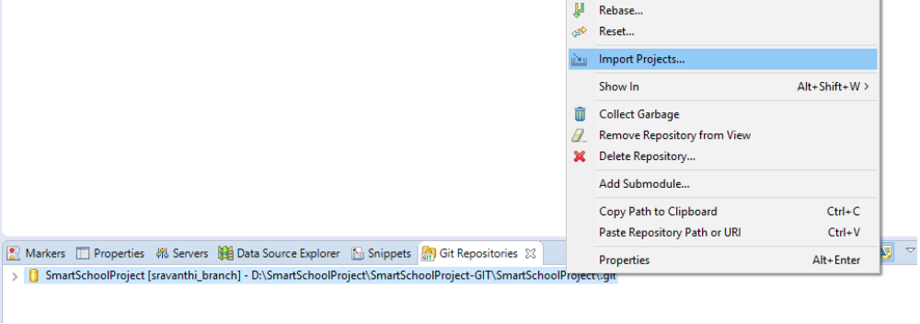

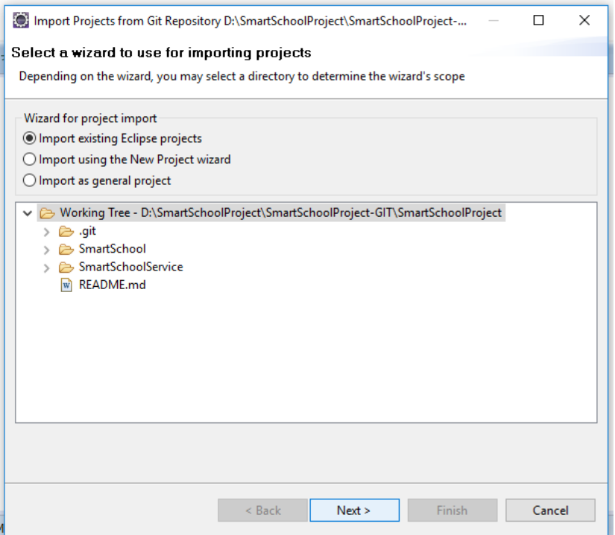
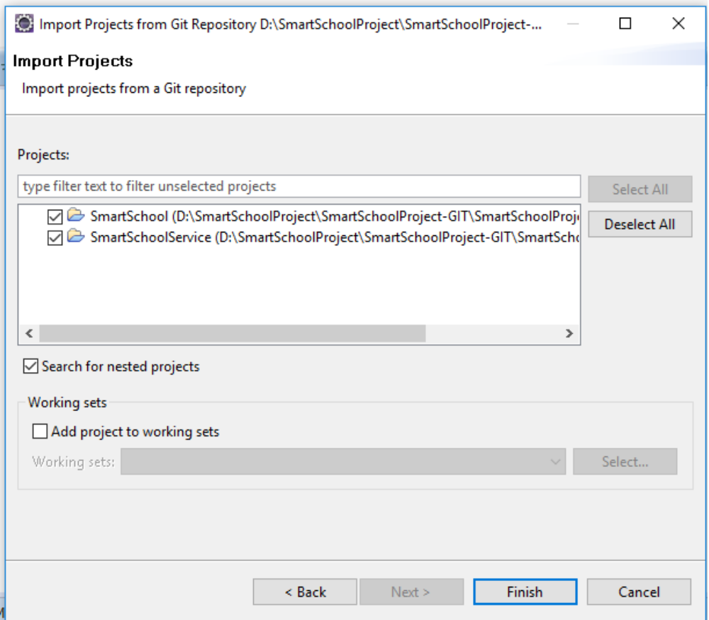

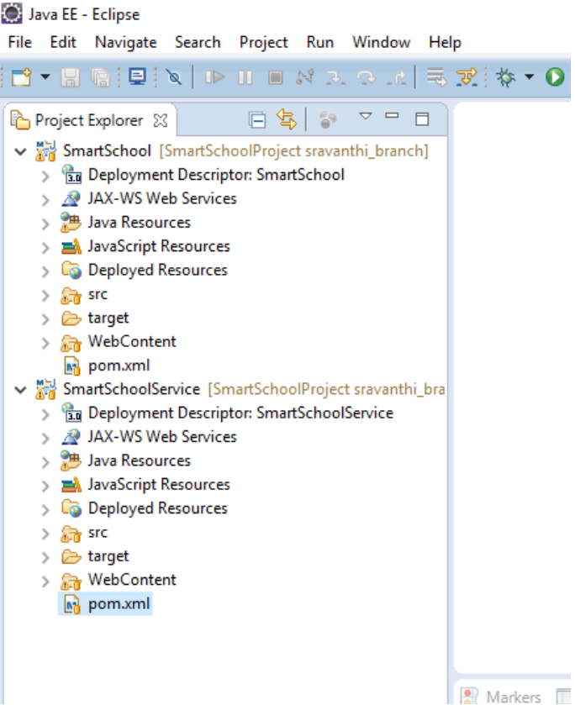

Setting up Apache Tomcat Server in eclipse :

Now you should already have Apache Tomcat zip file downloaded on your system.

Unzip that file as a folder.

Open eclipse and follow the below screenshots :-

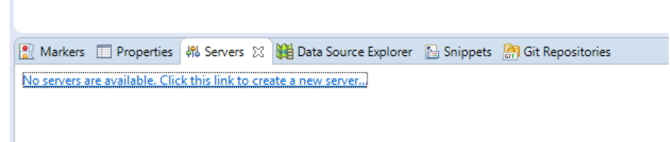

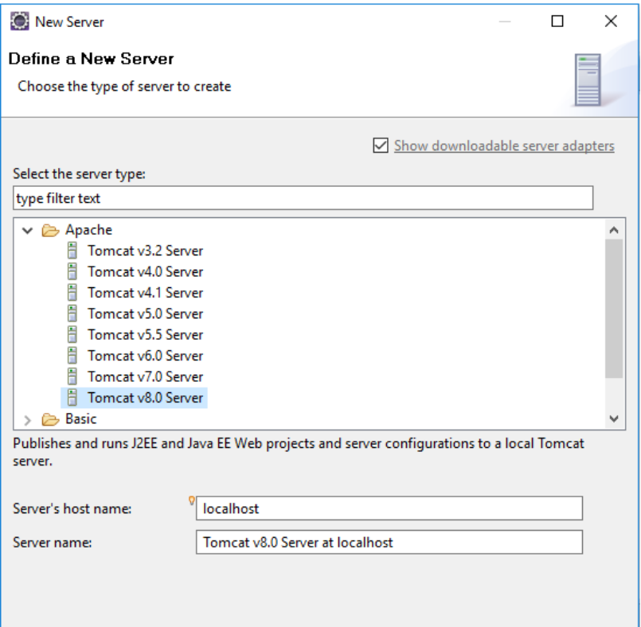
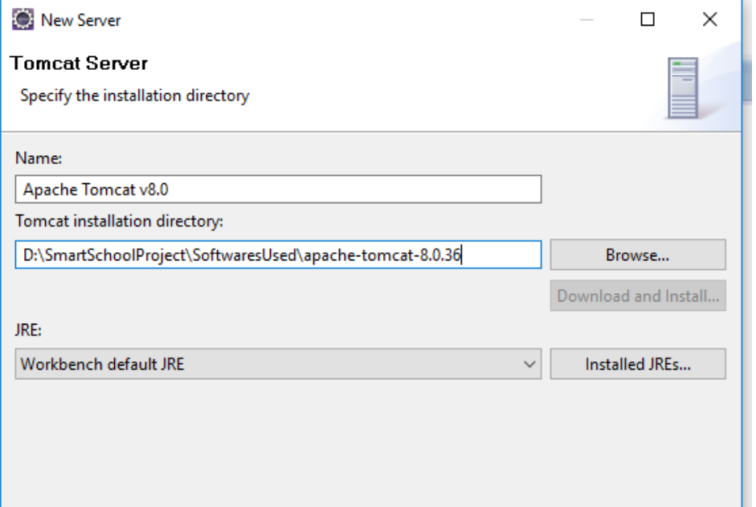

Handling issues during initial project startup on tomcat server :

First you need to run both the projects as “Run As → Maven Clean” and then “Maven Install”. First do it for the service project and then at the last do for the web project.

Make sure that both the maven install is success.

-----------------------------------------------------------------------------------------------------------------
While doing Maven clean/install, if you face the below issue :

[ERROR] No compiler is provided in this environment. Perhaps you are running on a JRE rather than a JDK?

Then it means that we are using JRE, not JDK.. For fixing that, please follow below steps :

Go to Window → Preferences → Java → Installed JREs.
And see if there is an entry pointing to your JDK path, and if not, click on Edit button and put the path you configured your JAVA_HOME environment

See below screenshot for example :

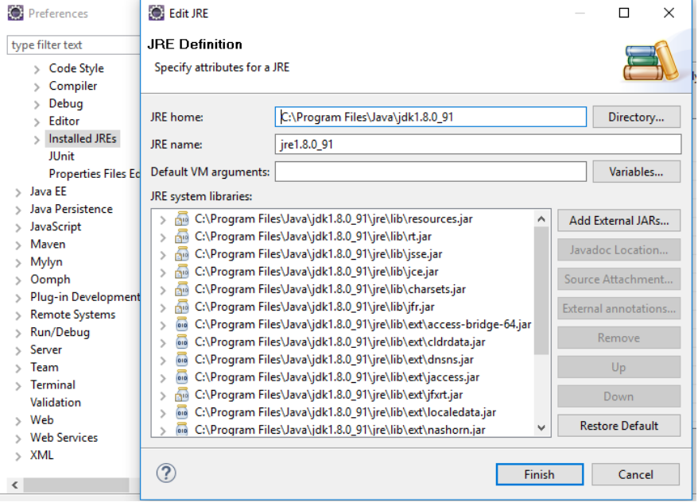

While running Maven install, if you see Build Failure with the below error message :
multi-catch statement is not supported in -source 1.5 (use -source 7 or higher to enable multi-catch statement)

Then do the below steps to fix it.

- Do maven clean.
- Do project clean. (Project--> clean).
- Maven install.
- If you see the above error message again with build failure, then clean the project from eclipse (Project--> clean).
- Once it is cleaned, then run Maven Install again. That should work fine.

-----------------------------------------------------------------------------------------------------
When you run the project for the first time on tomcat and if you got an error that is saying that the java files on the dependent project (say, java files in “SmartSchoolService” project) are not accessible or got NoClassDefFound error for the dependent project class files, then it means that even though you add the dependent project to the web project library as dependency, the tomcat server doesn't know that.

So you need to do the follow setup on tomcat configuration so that dependent project jar is picked.
(copied from : http://stackoverflow.com/questions/5603758/tomcat-throws-classnotfound-exceptions-for-classes-in-other-open-eclipse-project)

What you need to do is this:
- In Eclipse go to Window > Show View > Servers > and open tab called Servers
- In Servers, double click the server you want
- This action should open a window entitled Overview, with your selected Server in the TAB
- In this window select: Open launch configuration, and click the link.
- In the Edit Configuration window, select the tab called Classpath
- In the ClassPath textbox, select the line: User Entries
- Now push the button on the right entitled: Add Projects
- In the resulting Project Selection window select the external project you want the server to find via click.
- Close these windows by clicking Apply then OK as appropriate as you work up the stack
- Restart your server in the Overview window
Note : When you add the “SmartSchoolService” project, make sure you delete the automatically added unwanted entry “org.eclipse.m2e.MAVEN2_CLASSPATH_CONTAINER”

See below screenshot and make sure you have the configuration exactly same as in the screenshot.

